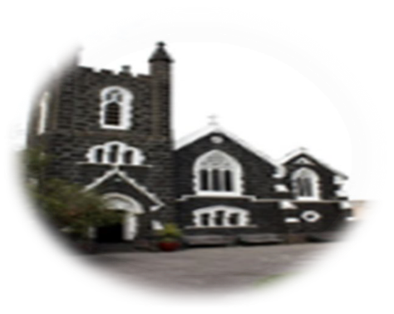

First Sunday of Lent, Year B,
18th Feb 2024
First reading: Genesis 9:8-15
God spoke to Noah and his sons, ‘See, I establish my Covenant with you, and with your descendants after you; also with every living creature to be found with you, birds, cattle and every wild beast with you: everything that came out of the ark, everything that lives on the earth. I establish my Covenant with you: no thing of flesh shall be swept away again by the waters of the flood. There shall be no flood to destroy the earth again.’ God said, ‘Here is the sign of the Covenant I make between myself and you and every living creature with you for all generations: I set my bow in the clouds and it shall be a sign of the Covenant between me and the earth. When I gather the clouds over the earth and the bow appears in the clouds, I will recall the Covenant between myself and you and every living creature of every kind. And so the waters shall never again become a flood to destroy all things of flesh.’
Responsorial Psalm
Psalm 24(25):4‐6,7b‐9
Your ways, O Lord, are love and truth to those who keep your covenant
Lord, make me know your ways. Lord, teach me your paths. Make me walk in your truth, and teach me: for you are God my saviour.
Your ways, O Lord, are love and truth to those who keep your covenant
Remember your mercy, Lord, and the love you have shown from of old. In your love remember me, because of your goodness, O Lord.
Your ways, O Lord, are love and truth to those who keep your covenant
The Lord is good and upright. He shows the path to those who stray, He guides the humble in the right path, He teaches his way to the poor.
Your ways, O Lord, are love and truth to those who keep your covenant
ST AUGUSTINE’S CATHOLIC CHURCH
BOURKE ST, MELBOURNE 3000
Parish Priest: Mons. Stuart Hall.
melbournebourkest@cam.org.au
TEL: +61 3 9412 8426
Second reading 1 Peter 3:18-22
Christ himself, innocent though he was, died once for sins, died for the guilty, to lead us to God. In the body he was put to death, in the spirit he was raised to life, and, in the spirit, he went to preach to the spirits in prison. Now it was long ago, when Noah was still building that ark which saved only a small group of eight people ‘by water’, and when God was still waiting patiently, that these spirits refused to believe. That water is a type of the baptism which saves you now, and which is not the washing off of physical dirt but a pledge made to God from a good conscience, through the resurrection of Jesus Christ, who has entered heaven and is at God’s right hand, now that he has made the angels and Dominations and Powers his subjects.
Gospel Acclamation Mt4:4
Praise to you, O Christ, king of eternal glory!
Man does not live on bread alone, but on every word that comes from the mouth of God.
Praise to you, O Christ, king of eternal glory!
Gospel Mark 1:12-15
The Spirit drove Jesus out into the wilderness and he remained there for forty days, and was tempted by Satan. He was with the wild beasts, and the angels looked after him.
After John had been arrested, Jesus went into Galilee. There he proclaimed the Good News from God. ‘The time has come’ he said ‘and the kingdom of God is close at hand. Repent, and believe the Good News.’
The Gospel of the Lord
ROSTER :10.30am: Priest: Rev. Brendan Lane; READERS: Jennifer, Terry
ALTAR SERVERS: Hananta, Marfel, Melinda, Aryo; MOCs: April, Marina S8pm: Priest: Rev. Peter Carrucan READER TBC
Thank you to our visiting priests assisting this weekend.
NOTICES: Come and pray the Stations of the Cross/Via Crucis every Friday night at 5.30pm in the Church from 16th Feb to 22 March, inclusive.
GREAT WOMEN OF FAITH EXHIBITION Great Women of Faith is an exhibition of portraits by artist Barbara Skorupa. It depicts various women saints, religious and laity of the Church. It is done in the pop art style giving a freshness to the depiction of the women. The exhibition can be seen at St Patrick’s Cathedral, 1 Cathedral Place from the 1st March to the 10th of March, 2024.
It’s not too late to join the scripture group for Lent. Wednesdays at 7pm in St Joseph’s Hall (behind St Augustine’s Church)
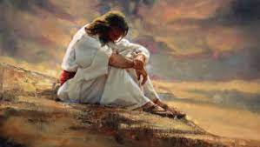
Thanks to all who attended Pancake Tuesday -a fun time was had by all!
MASS TIMES:
10.30AM and 8PM
Weekdays:
Tues, Wed, Fri at 1.05pm

Monsignor Stuart last week broke a rib and two vertebrae. He is slowly recovering. Please pray for him as the healing process begins.

